- Shit Agent Action
- Create a New Shift Log Draft:
"Create a shift handover for unit CDU-101"
Creates a new shift package in DRAFT state for unit CDU-101.

- Add Equipment Abnormalities or Safety Isolations (LOTO):
"Add abnormality: Compressor C-101 high vibration reading 4.5 mm/s to CDU-101 draft"
"Add LOTO isolation: Isolation on Pump P-101A discharge valve for seal replacement"

- Submit Handover Package:
"Submit shift handover for CDU-101"
Transitions status from DRAFT to SUBMITTED and logs an audit record.

- Supervisor Review & Approval (Requires SHIFT_SUPERVISOR role):
"Approve shift handover for CDU-101"
Transitions status to PENDING_ACKNOWLEDGEMENT for incoming crew.
"Return handover for CDU-101 because LOTO list is incomplete"
Returns status to RETURNED with the reason logged in audit trail.

- Incoming Crew Acknowledgement (Requires INCOMING_OPERATOR role):
"Acknowledge LOTO isolation on P-101A and accept shift handover for CDU-101"
Confirms safety item acknowledgement and transitions status to COMPLETED.

- Querying Active Isolations & Audit Trail:
"What are the active LOTO isolations for unit CDU-101?"
"Show audit history for handover SHO-2026-CDU101-01"

- Core Logical Pillars of orchestrator.py
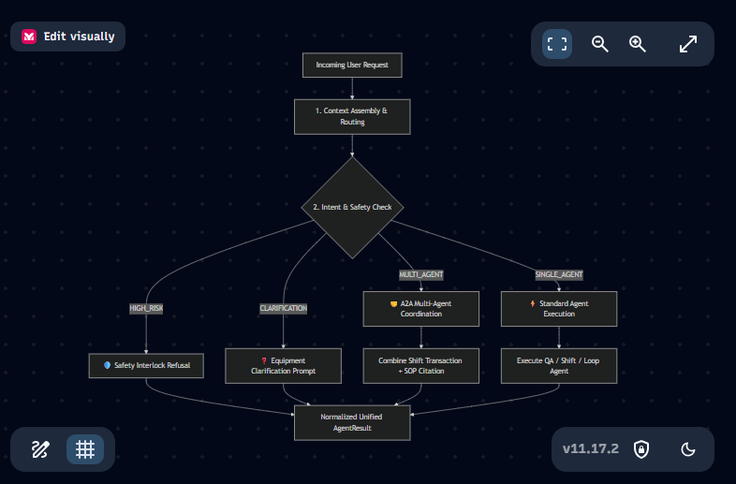
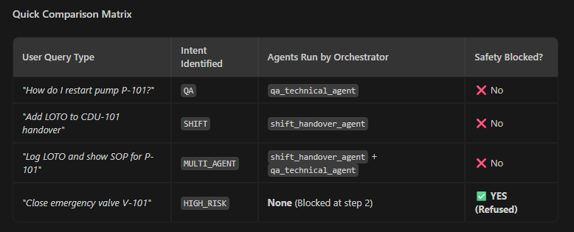

Using keyword and confidence level (Regex)

- OOPs used case
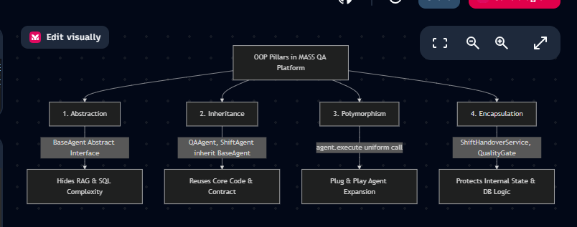

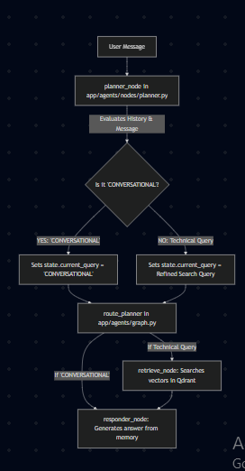

- With registry.py, the system gains 3 major architectural advantages:
Zero Tight Coupling: orchestrator.py does not import individual agent implementation classes. It only knows string keys (e.g. "shift_handover_agent").
Plug-and-Play Extensibility: If you build a new agent tomorrow (e.g. HSE_Representative_Agent), you simply call agent_registry.register(hse_agent). You do NOT need to edit a single line of orchestrator.py!
Runtime Inspection & Diagnostics: The API can query agent_registry.list_agents() to return active agent capabilities to the frontend UI.

- Agents/qa/adpter.py
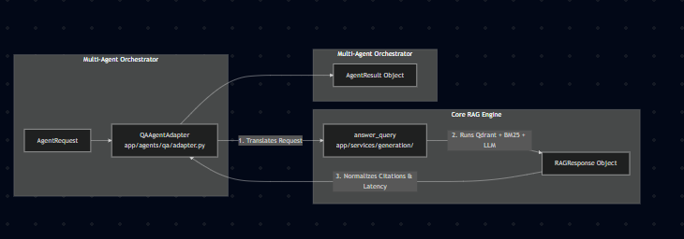
- D:\Chatboat\app\agents\shift

